**Assignment 2**

**Description:**

1. Assume that you have the following JavaScript code:

Code –

<body>

<p>Click the button to demonstrate the prompt box.</p>

<button onclick="promptFunction()">Try it</button>

<p id="demo"></p>

<scipt>

function promptFunction() {

var prompttest = prompt("Please enter your name", "iiht code");

if (prompttest != null) {

document.getElementById("").innerHTML =

"Hello " + prompttest + "! How are you today?";

}

}

</scipt>

</body>

let’s display a message containing a user name or any string and find out any code error if there and correct them?

**Show the output.**

<!DOCTYPE html>

<html lang="en">

<head>

    <meta charset="UTF-8">

    <meta http-equiv="X-UA-Compatible" content="IE=edge">

    <meta name="viewport" content="width=device-width, initial-scale=1.0">

    <title>Document</title>

</head>

<body>

    <p>Click the button to demonstrate the prompt box.</p>

    <button onclick="promptFunction()">Try it</button>

    <p id="demo"></p>

    <script>

        function promptFunction() {

            var prompttest = prompt("Please enter your name", "iiht code");

            if (prompttest != null) {

                document.getElementById("demo").innerHTML =

                    "Hello " + prompttest + "! How are you today?";

            }

        }

    </script>

</body>

</html>

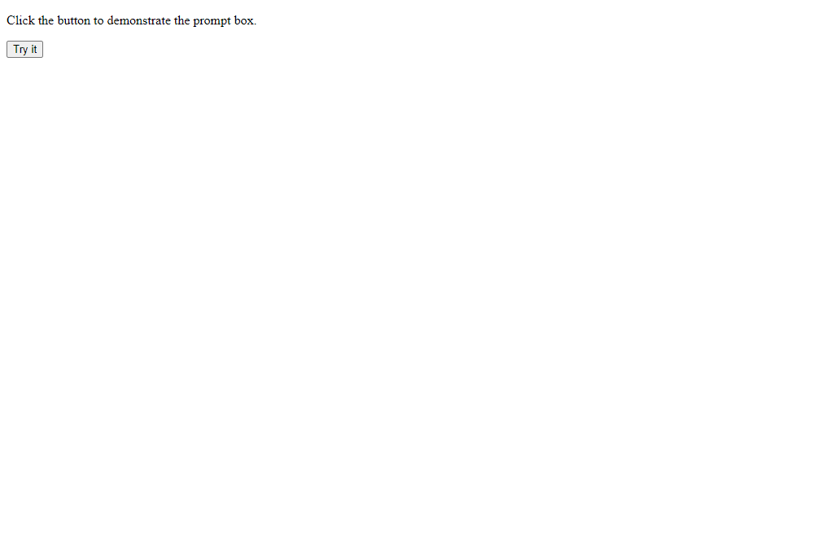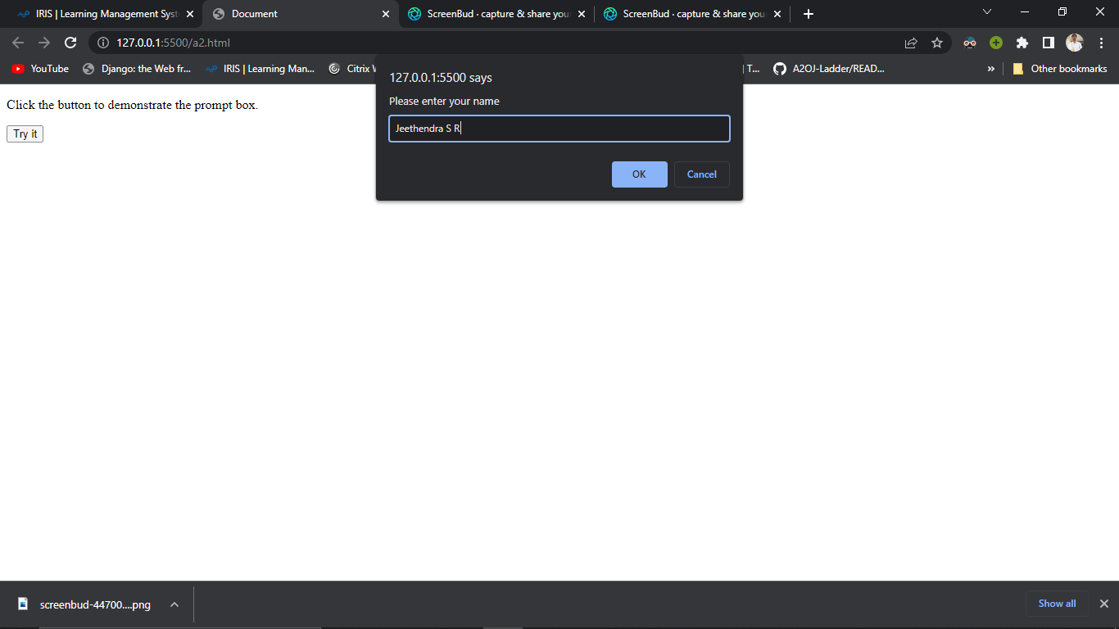

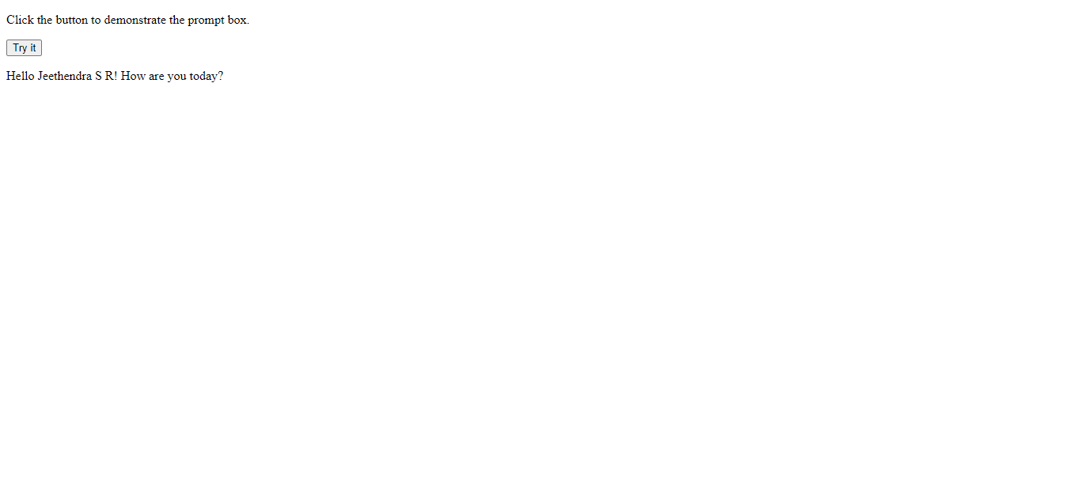

1. **Get the by entering Name or few value output?**

**Yes**

1. **Using** document.getElementById **can we store a variable in above code or not.**

**yes**

1. **Find and debug the code for find out the above output.**
2. **Done**

**Output:**

**Performance Outcomes:**

Upon successful completion of the assignment, the participant is well versed in

1. How to take use input using getElementById function and how to store value.
2. Knowledge to display the entered value from user and show them on output.
3. Able to know how can fix the javascript code snap if any debugging error.